**Neural X**

**Final Year Project Proposal**

**Session 2016-2020**

**4th Year Students**

A project submitted in partial fulfillment

Of

BS in Computer Science (CUI)



Department of Computer Science

COMSATS University Islamabad, Lahore

25 August 2019

**Project Registration**

|  |  |  |  |  |  |  |  |
| --- | --- | --- | --- | --- | --- | --- | --- |
| Project ID (for office use) | | |  | | | | |
| Type (Nature of project) | | | **[ ] Development** [ ] **R**esearch [ * ] **R**&**D** | | | | |
| Area of specialization | | |  | | | | |
| **Project Group Members** | | | | | | | |
| Sr.# | Reg. # | Student Name | | CGPA | Email ID | Phone # | Signature |
| (I) | FA16-BCS-117 | Muhammad Ali Malik | | 3.28 | [ali_1malik@hotmail.com](mailto:ali_1malik@hotmail.com) | 0322 4109468 |  |
| (ii) | FA16-BCS-111 | FareehaSohail | | 3.09 | ranasfary143@gmail.com | 0302 7579802 |  |
| (iii) | FA16-BCS-179 | Tayyaba Akram | | 2.87 | taibaakram225@gmail.com | 0307 5077598 |  |
| Name & Signature of Batch Advisor  (If students are eligible for FYP) | | | | Mr. Imran Latif | | | |

* **Plagiarism Free Certificate**

This is to certify that, I am MUHAMMAD ALI MALIK S/o SARFRAZ NAWAZ MALIK, group leader of FYP under registration number CIIT/SDP-FA16-BCS-117/LHR at Computer Science Department, COMSATS University Islamabad, and Lahore. I declare that my FYP proposal is checked by my supervisor and the similarity index is 8% that is less than 20%, an acceptable limit by HEC. Report is attached herewith as Appendix A.

Date: 11/09/2019 Name of Group Leader: Muhammad Ali Malik Signature: _____________

Name of Supervisor: [Mr. Imran Raza](http://www.ciitlahore.edu.pk/PL/profile.aspx?employeeid=72) Co-Supervisor (if any): [Dr. Syed Asad Hussain](https://lahore.comsats.edu.pk/Employees/9)

Designation: Assistant Professor Designation: Deen

Signature: _____________________ Signature: _____________________

**Approval of FYP Management Committee**

Committee Member 1: Name: _____________________

[ ] Accept [ ] Defer [ ] Reject Signature: _______________

*Remarks: _____________________________________________________________________

Committee Member 2: Name: _____________________

[ ] Accept [ ] Defer [ ] Reject Signature: _______________

*Remarks: _____________________________________________________________________

Convener: Name: _____________________

[ ] Accept [ ] Defer [ ] Reject Signature: _______________

*Remarks: _____________________________________________________________________

**Abstract:**

Neural X is a system based on Brain Computer Interface (BCI) for physically challenged people. As there are millions of people in Pakistan who are physically impaired which include disorders such as cerebral palsy, spinal injury etc. This limits a person’s ability to move or perform any physical task. These people find difficulty in carrying out their simple daily life chores. Neural X, our system based on BCI, helps to fill this void. Neural X provides the intelligent use of EEG signals to control actuators. The interface provides a direct communication between the brain and the object to be controlled. Using Emotiv Epoc headset brain EEG signals will be read and transmitted as input into the system. After the preprocessing and classification, the output will be sent to an actuator via transceivers. Then the actuator will perform the desired function. Moreover, machine learning and data mining techniques will be used to increase the effectiveness of the system.

**Table of contents**

1. Introduction 7

1.1 Non-Invasive: 7

1.2 Semi Invasive: 8

1.3 Invasive: 8

2. Motivation and Scope: 9

3. Related Work: 9

4. Goals and Objectives: 11

4.1 Main Goals 11

4.2 Objectives 12

5. Proposed System: 12

5.1 Signal Acquisition 12

5.2 Pre-Processing 13

5.3 Feature extraction 13

5.4 Classification 14

6. Individual Tasks: 15

7. Tools and Technologies: 15

8. Gantt Chart: 16

9. Conclusion: 16

10. Future Work: 17

11. References: 18

**List of Figures**

Figure 1 Headset to Capture EEG Signal 8

Figure 2 Electrocorticography 9

Figure 3 Micro-Electrodes 9

Figure 4 Brain Computer Architecture 13

Figure 5 MNE Spectogram 14

# **1. Introduction**

Brain Computer interface is system through which the brain can connect to a device which enables signals from the brain to be rerouted towards an external environment to conduct an activity e.g. an actuator.

Hence, BCI measures activity of neurons in the Central Nervous System (CNS), acquires those signal then enhances or improves the original CNS signals, then changes the way it interacts with the external and internal environment [1].

In the 1970s research started on BCI in the University of California. Its focus was mainly on research and development of neuro prosthetics applications which would help people who were blind , deaf and physically challenged[2].BCI detects the smallest of changes in the energy radiated by the brain when you think in a certain way. A BCI recognizes specific energy/ frequency patterns in the brain.

 BCI can be separated in three categories depending on the method used to collect brain signals.

## **1.1 Non-Invasive:**

The sensors or headset is placed on the scalp to measure frequency of neurons or in other words potentials (EEG).

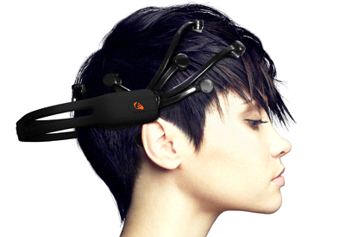

Figure 1 Headset to Capture EEG Signal [3]

## **1.2 Semi Invasive:**

The electrodes are placed on the exposed surface of the brain (ECOG).

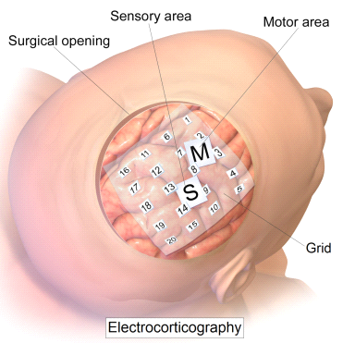

Figure 2 Electrocorticography [3]

## **1.3 Invasive:**

The micro electrodes measure the activity of a single neuron which are placed inside the brain (Cortex)

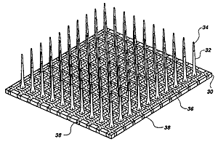

Figure 3 Micro-Electrodes [3]

This project will use the non-invasive method to collect the brain signals (EEG).

This works in four main steps:

* Collecting Brain Signals
* Interpreting Brain Signals
* Classification of unseen example
* Outputting commands to a connected actuator

# **2. Motivation and Scope:**

* Many of Pakistan’s population are widely affected with the motor consequences of serious injury – ranging up to 27 million people. These numbers encourages us to develop bioengineering control devices to help these physically impaired people[4].
* There is a worldwide research going on about the BCI Recently Elon Musk ( USA top Entrepreneur) entered the industry, announcing a $27 million dollars investment in Neural link, A program based on BCI to help improves human communication with respective to Artificial Intelligence(AI) [5].
* BCI makes the chances to extend to Human Computer Interfaces (HCI).That allows the interaction between brain, eyes and body to computer or robot.
* BCI helps in the field neurology as this provides an insight to how the human brain functions.
* The Inclusion of non- medical applications has also been opted to further widen the scope of research. Research has shown that people working on BCI are also moving towards the development of hands free application in light of BCI.

# **3. Related Work:**

In 2005, A man named Matt Nagle was the first person to use an artificial hand based on BCI. He could control the robotic arm by thinking of its movement, this was implemented by using 96- electrodes implanted on his Brain gate on the right gyrus [6].

In Emory University, Atlanta a research that was led by Roy Baka and Phillip Kennedy, eventually made them the first to have the high enough signals generated by a brain implant on a human to simulate movement. In 1998, a patient named Johnny suffering from Locked-in syndrome was given a brain implant and he eventually learned how to control a computer cursor [6].

An electrical engineer named William Dobell did experiments based on the vision for blind people. A sensation of seeing light was achieved when a BCI containing 67 electrodes were placed into patients visual cortex. In the system, a special glass was given to a blind person to wear. The glasses had a miniature camera attached to it which would take pictures of the surrounding and then relay to them on a computer which were further then transmitted to the electrodes with the brain [7].

The Oxford Neural Interfacing Group was founded for the research of new techniques and ways to control actuators using EEG signals, many robotic prostheses have been made to help disabled people or people losing their arms or hands. By which the means a user controls it is much primitive due to which the full potential or scope of them has not been able to be realized, though they perform the functions just like that of a real limb [8].

People who have disorders such as Amyotrophic Lateral Sclerosis (ALS) or Locked in Syndrome are not able to communicate although they are aware of their surroundings. Abhinav have developed a low-cost solution of Brain Keyboard Application. This application has 26 alphabetical keys with a space and a delete key. All keys are scanned by a square selection box and when the person blinks his eyes that particular selected key gets pressed and is outputted on the screen [9].

In Cambridge Research into Impaired Consciousness (CRIC) group, researchers developed the computational and empirical tools that used EEG for characterizing different conscious state like sleep, anesthesia etc. This project was funded by James S. McDonnell Foundation [10].

If we want robots to do what we desire then they will first have to understand us. For this purpose,   
A Computer Science and Artificial Intelligence Laboratory (CSAIL) of MIT and Boston University, designed a system with which lets people correct a robot’s mistake by using their mind only. Using EEG signals from brain system could detect if the person has noticed a mistake in the robot’s performance about Object sorting task. In a space of 10-30 milliseconds, brain waves were classified by the system. The robot used in this research was called “Baxter”[11].

Neuralink, a company founded by Elon Musk and his team had the long term goal to achieve Symbosis. In July, 2019, Neuralink announced a project name “sewing machine-like” device, the device could implant very thin threads in a brain [12].

At University of California, Berkeley a research was led by Yang Dan in which he reproduced pictures seen by cats by decoding neuronal firings. An array of electrodes was implanted in thalamus of cats having sharp eyes. A total of 177 brain cells were used to decode the signals coming from retina. The neuron firings were recorded by showing cats eight different short movies [13].

# **4. Goals and Objectives:**

## **4.1 Main Goals**

* One of the goals of BCI related to people disabled with neuromuscular disorder such as Amyotrophic lateral sclerosis (ALS) stroke or spinal cord injury is to restore their functions or to give them the ability to perform important tasks.
* BCI will help people to interact, influence or change certain things by getting electrical or EEG signals from brain.
* To deal patients having neurological developmental disorders stroke and elderly subjects.
* To provide neuronal rehabilitation for serious injuries.
* Actuators will help locked-in users and people who are unable to move or are physically challenged.
* It will be helpful in situations where response time is crucial.
* This will provide ease for people by providing them mind-controlling machines rather than those controlled by physical body parts.

## **4.2 Objectives**

* Information processing by using brain signals or EEG signals
* To provide an alternative way to control a prosthesis directly from brain.
* To be used for rehabilitation and restoration for disabilities and brain strokes.
* To help disabled people to perform tasks.

# **5. Proposed System:**

Following is the system architecture diagram and main modules of proposed system:

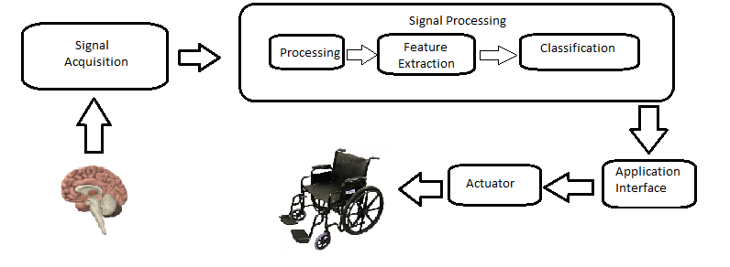Figure 4 Neural X System Architecture

## **5.1 Signal Acquisition**

The Brain signals will be extracted from the user using a Non-Invasive method (Emotiv Epoc headset) in the form of electroencephalography (EEG).EEG measures brain activity which is caused by the flow of neurons. The user will wear a headset which will capture the brain signals. The signals frequency will be recorded.

## **5.2 Pre-Processing**

The EEG signals attained from the headset have to undergo pre-processing as the signals that are picked up from the scalp are not necessarily and accurate representation of the signals originating from the brain due to factors such as noise.

We will use Python referencing the MNE library EEG analysis to preprocess Data. MNE-Python supports a variety of preprocessing approaches and techniques (short-time Fourier transform (STFT), Maxwell filtering, signal-space projection, independent components analysis, filtering, down sampling, etc.).

This can help clean up our data by performing independent components analysis. Then this data will be represented by a spectrogram.

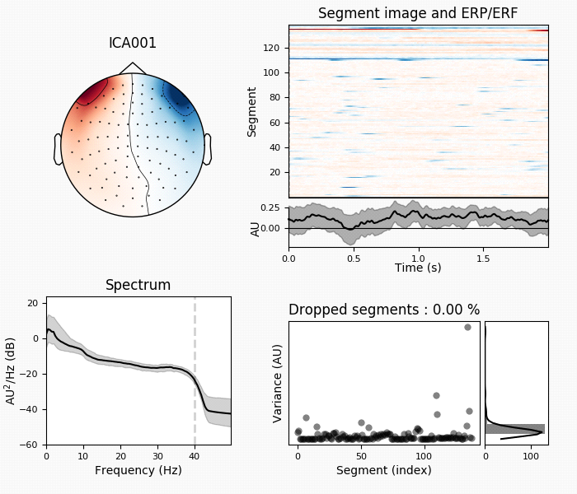

Figure 5 MNE Spectrogram [14]

## **5.3 Feature extraction**

As EEG signals are complex it becomes difficult to extract the feature vectors that we require therefore we will apply a signal processing algorithm to find the required information. There are variety of feature extracting methods, some of them are: Band powers, Cross-correlation between EEG band powers frequency representation and time-frequency representation. This will result in the output of filtered labeled data.

## **5.4 Classification**

The labeled data will be split into Train (70%) and Test (30%). The labeled train dataset will be used to train Python (Pandas) machine learning algorithms such as Random Forrest Classifier, Bernoulli Naïve Bayes etc.

After the models are trained then test data will be used to predict the classification from these models. The label will be used to check the accuracy between the predicted result and the actual labeled result. The Model with the highest accuracy score will be chosen for implementation.

The Emotiv Epoc headset will be used by the user to generate EEG signals. The signals will be preprocessed and then will be used as input for the selected ML model. The model will classify the signal. This output of the signal will be displayed on an interface.

Then by the use of transceivers, the output signal (classification) will be sent to an actuator which would perform the desired function according to that particular classification.

# **6. Individual Tasks:**

In this part, Table 1 indicates the distribution of tasks between the members of the group.

|  |  |  |
| --- | --- | --- |
| **Group Members** | **Registration ID** | **Tasks** |
| FAREEHA SOHAIL | FA16-BCS-111-C | Research & Analysis  Documentation  Feature Extraction  Requirement Engineering  Testing |
| MUHAMMAD ALI MALIK | FA16-BCS-117-C | Predictive Model Training  Classification of unseen example  Connecting of Microprocessors  Mapping Model on Actuator  Requirement Engineering  Testing Documentation |
| TAYYABA AKRAM | FA16-BCS-179-C | Pre-Processing of Raw Data  Hardware connectivity  Database Development  Requirement Engineering Documentation  Testing |

Table 1. Individual Tasks

# **7. Tools and Technologies:**

**Languages:**

Python

Pandas

Anaconda

C/C++

Java Script

**Tools:**

Arduino

ZigBee

Wi-Fi

Emotiv Epoc

Bluetooth

# **8. Gantt Chart:**

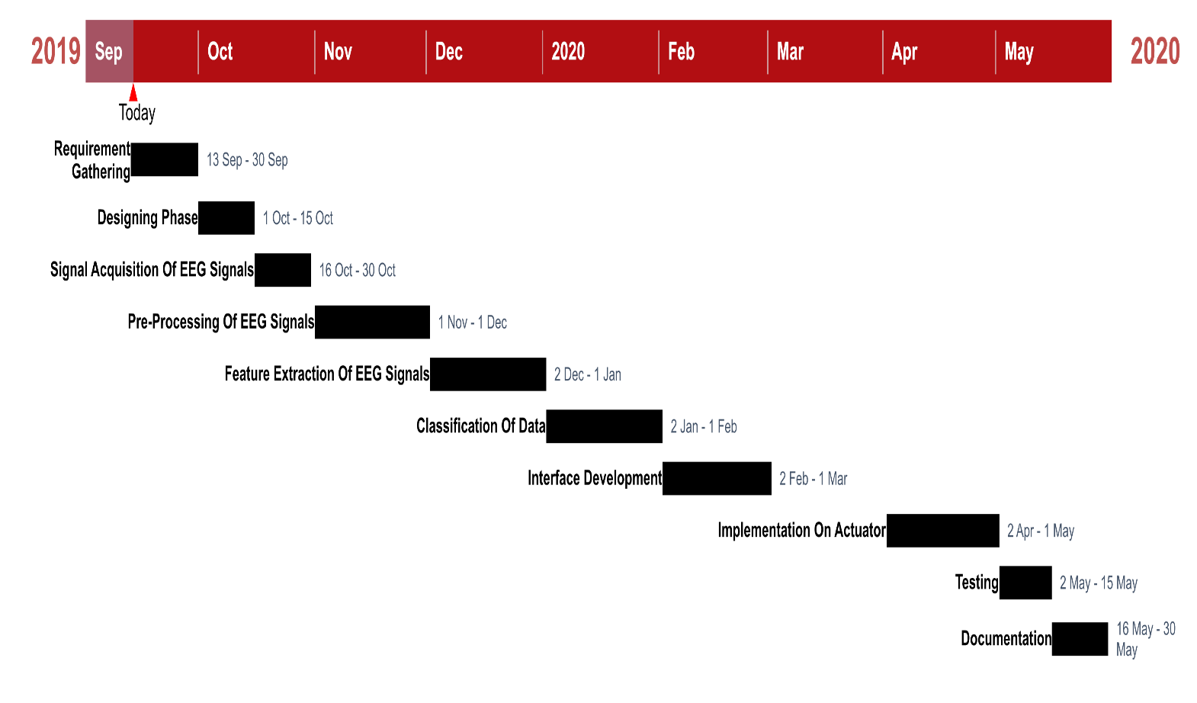

# **9. Conclusion:**

The proposed model will help to provide natural and real-time control of assistive devices that would be helpful to people with paralysis, limb loss, restore function or aid rehabilitation after injury. Neural X will allow them to interact with their environment without being dependent on their peripheral muscles. It will convert and transmit human interactions into appropriate motion commands for actuators. The EEG signals attained from the headset will be used as an input into our system. The signals will be classified by using the selected ML model. After the classification it will be sent to an actuator via transceivers.

# **10. Future Work:**

* Artificial intelligence can be used to judge environment conditions and give the user suggestions to activate actuators (e.g. turn on Air Conditioner during a hot day).
* Using machine learning techniques and data mining adapt to a new user more quickly and efficiently
* Making a BCI compatible environment in public places.
* Multiple actuators can be controlled by a single BCI system.

# **11. References:**

[1]“Brain Computer Interface an Intro’’ from [https://www.sciencedirect.com/topics/neuroscience/brain-computer-interface](https://www.sciencedirect.com/topics/neuroscience/brain-computer-interface%20HYPERLINK%20%22http://www.pakistaneconomist.com/%22/) accessed on August 27, 2019.

[2]”Towards Data Science” from<https://towardsdatascience.com/a-beginners-guide-to-brain-computer-interface-and-convolutional-neural-networks-9f35bd4af948>, accessed on August 27, 2019

[3]"Intro to Brain Computer Interface" from <http://learn.neurotechedu.com/introtobci/>accessed on August 27, 2019.

[4]”Disability in Pakistan” from <https://en.wikipedia.org/wiki/Disability_in_Pakistan> accessed on August 27, 2019.

[5]”Neural Link” from <https://www.businessinsider.com/elon-musk-neuralink-raises-27-million-2017-8> accessed on August 28, 2019.

[6]”Human BCI research” from <https://en.wikipedia.org/wiki/Brain%E2%80%93computer_interface>accessed on August 27, 2019.

[7]”William Dobelle, 62, Engineer aided Artificial vision for blind” from <https://www.latimes.com/archives/la-xpm-2004-nov-02-me-dobelle2-story.html> accessed on August 26, 2019.

[8]”Peripheral Nerve Interfacing” from <https://www.nds.ox.ac.uk/research/oxford-neural-interfacing> accessed on August 26, 2019.

[9]”Brain Keyboard using Neurosky Mind wave Mobile and JAVA” from <https://www.pantechsolutions.net/blog/brain-keyboard-using-neurosky-mindwave-mobile-and-java/> accessed on September 13, 2019.

[10]”Wolfson Brain Imaging Centre” from <https://www.wbic.cam.ac.uk/userdirs/sc672> accessed on September 13,2019.

[11] “Brain-controlled robots” from <http://news.mit.edu/2017/brain-controlled-robots-0306>

[12] “NEURALINK” from <https://www.neuralink.com/> accessed on September 13,2019.

[13]”Reconstructed movie showing animal view of world proves scientists have a good understanding of how the brain processes visual information” from <https://www.berkeley.edu/news/media/releases/99legacy/10-15-1999.html> accessed on September 13,2019.

[14]"Overview of MEG/EEG analysis with MNE-Python" from <https://www.nmr.mgh.harvard.edu/mne/stable/auto_tutorials/intro/plot_introduction.html> accessed on August28, 2019.